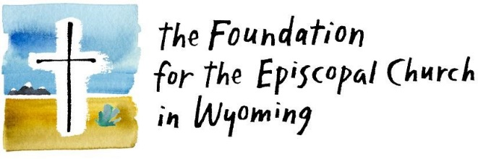

Church Name:
Town/City:
Amount of Grant Request:
Name of Primary Contact:
Preferred Phone Number:
Preferred Email Address:
Is this a Collaborative Grant?

If yes, list the name(s) and locations of the collaborative church(es):

Summary
Please provide a brief summary (1-3 sentences) about your grant application.

What is the purpose of your proposed initiative?
Write a short narrative (1-2 paragraphs) of your project, including a description of how your initiative will support the current funding priorities and aims to grow the church in depth (i.e., spiritual transformation) and/or in breadth (i.e., making the church relevant to those outside the church).

Who are the key project/program personnel and what roles do they have in bringing your project to life?

What does success look like for this project? How will you determine if your initiative is impactful?

What commitment has your local congregation made to support this initiative?

Does this initiative include any partnerships? If so, give a brief explanation of the partnering organization and its role in the project.

What is the timeline for your project?

Are there any planned events and/or dates associated with this initiative that would be good to know about for publicity?

Compliance
Is your church in compliance with the Diocese on parochial reports, annual audits, and assessments?
If not, please confirm your plan to get into compliance:

Attachments

Please attach the following documents with your completed application:
- Letter of support from your Vestry (with at least 2/3 of vestry signatures)
- Current financial statements
  - Statement of Profit and Loss from the month ending prior to your application (Statement of Activities in FastFunds)
  - Balance sheet for the month ending prior to your application (Statement of Financial Position in FastFunds)
- Copies of estimates, quotes, or other supporting documents

- If partnering with another entity (church or non-profit), include:
- Letter of support from the partnering entity (church or non-profit) demonstrating their partnering role and commitment to the initiative, or a benefiting community member
- If funds will be managed by a partnering entity, include current financial statements for the entity responsible for the oversight of grant dollars

Project Budget Form
PROJECT INCOME – List each actual and/or anticipated source of funding for this project. If you have a custom budget, feel free to attach it separately.
Funding Sources | Amount
The Foundation for the Episcopal Church in Wyoming Grant
Other Grants
Fundraising
Parish Contribution
In-Kind Donations
Other Income (specify)
Total Project Income

PROJECT EXPENSES – List anticipated expenses for this project such as marketing, personnel, equipment, supplies, services, travel, etc.
Expenses | Amount
Total Project Expenses

Any necessary budget narrative (optional):

Thank you for completing your Foundation for the Episcopal Church of Wyoming grant application. You may mail the completed form to
123 S. Durbin, Casper, WY 82601 or email it to Kira at Kira@episcopalwy.org.

