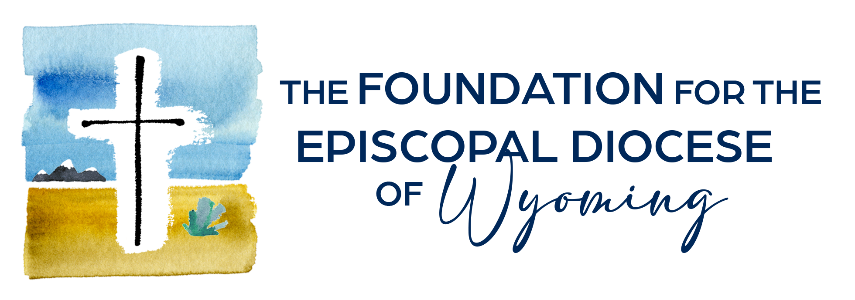

**NEWS RELEASE**

***The Foundation for the Episcopal Diocese of Wyoming***

**For immediate release: August 4, 2025**

**Contact:** Kristi Wallin, Executive Director at [kristi@episcopalwy.org](mailto:kristi@episcopalwy.org) or 307-760-3898.

**Foundation for the Episcopal Diocese of Wyoming Awards $100K to St. John’s in Jackson for Immigrant Advocacy Project**

The Foundation for the Episcopal Diocese of Wyoming recently awarded $100,000 to St. John’s Episcopal Church in Jackson to support the Wyoming Immigrant Advocacy Project (WIAP), a local nonprofit that supports individuals and families in the Teton region who face financial barriers to immigration services.

 WIAP is a nonprofit immigration law organization in Wyoming that promotes and defends the rights of all immigrants through free and low-cost legal services, public education, and systemic advocacy.

 “We are a faith founded on the story of the immigrant and the outsider,” says the Rev. Mary Erickson, associate rector of St. John’s, Jackson. “In our Baptismal Covenant, we commit to striving for justice and peace among all people and respecting the dignity of all human beings. Supporting WIAP is a powerful way to live into these values.”

 WIAP’s services include direct representation, community outreach and educational programming, and pro bono attorney training.  Prior to WIAP, the only option for someone needing immigration legal assistance was to retain private counsel, which is often cost prohibitive.

 Since launching services in fall 2024, WIAP has served young adults seeking to sponsor their parents for permanent residence and parents wishing to sponsor their children, victims of crime, asylum seekers, and long-time community members seeking an understanding of their immigration options.

For almost forty years, The Episcopal Church, in partnership with the federal government, has maintained an unwavering commitment to expansive ministries of support for refugees and immigrants, says the Rt. Rev. Todd Ousley, Bishop Provisional of the Wyoming Episcopal Church. “With this grant, we send a clear message to immigrants that they are not alone, and that Episcopalians will continue to walk beside them despite draconian reductions in U.S. government support.  We look forward to our enhanced partnership with WIAP as they provide critical legal services to immigrants in need across our great state. As followers of Jesus, we can do no less.”

 Approximately 23,000 Wyoming residents were born abroad, and an estimated one in three of those individuals is undocumented, according to WIAP.

 While Jackson’s tourism and construction industries rely heavily on immigrant labor, communities across Wyoming also depend on immigrant labor to fuel their economies.

 Due to an increase in clients seeking legal consultations, WIAP is currently working through a waitlist of about 40 individuals. To meet the growing demand for services, WIAP plans to expand its staff in 2025. WIAP currently manages 19 cases involving 29 individuals. Over the next year, it aims to increase its caseload to about 50 and offer four consultations per week.

Positive case outcomes that help clients stay in their communities and build stable lives are WIAP’s primary goal and the clearest measure of its success.

 St. John's will facilitate opportunities, such as 'Know Your Rights' events and materials, to equip churches across the Episcopal Church in Wyoming to support their immigrant communities with practical help and spiritual resources.

 “The Episcopal Church champions and advocates for humane policy towards migrants because of our belief that every human being, regardless of immigration status, is a child of God and must be treated with dignity,” Erickson says. “This grant proposal comes out of that rich tradition.”

 To learn more about WIAP, or for those in need of services, visit [https://wyomingiap.org](https://wyomingiap.org/).

For more information about the grant, contact The Rev. Mary Erickson, St. John’s Episcopal Church, at [mary@stjohnsjackson.org](mailto:mary@stjohnsjackson.org).

 ###